http://localhost:8080/reward/point

[

    {

        "rewards": [

            {

                "monthYear": "202303",

                "transactions": [

                    {

                        "customerid": "1",

                        "date": "2023-03-10T05:00:00.000+0000",

                        "amount": 60.0

                    },

                    {

                        "customerid": "1",

                        "date": "2023-03-11T05:00:00.000+0000",

                        "amount": 40.0

                    }

                ],

                "monthlyPoint": 10.0

            },

            {

                "monthYear": "202304",

                "transactions": [

                    {

                        "customerid": "1",

                        "date": "2023-04-01T04:00:00.000+0000",

                        "amount": 140.0

                    }

                ],

                "monthlyPoint": 130.0

            },

            {

                "monthYear": "202302",

                "transactions": [

                    {

                        "customerid": "1",

                        "date": "2023-02-25T05:00:00.000+0000",

                        "amount": 120.0

                    },

                    {

                        "customerid": "1",

                        "date": "2023-02-26T05:00:00.000+0000",

                        "amount": 80.0

                    }

                ],

                "monthlyPoint": 120.0

            }

        ],

        "totalPoint": 260.0

    },

    {

        "rewards": [

            {

                "monthYear": "202303",

                "transactions": [

                    {

                        "customerid": "2",

                        "date": "2023-03-15T04:00:00.000+0000",

                        "amount": 73.0

                    },

                    {

                        "customerid": "2",

                        "date": "2023-03-12T05:00:00.000+0000",

                        "amount": 95.0

                    }

                ],

                "monthlyPoint": 68.0

            },

            {

                "monthYear": "202304",

                "transactions": [

                    {

                        "customerid": "2",

                        "date": "2023-04-02T04:00:00.000+0000",

                        "amount": 10.0

                    }

                ],

                "monthlyPoint": 0.0

            },

            {

                "monthYear": "202302",

                "transactions": [

                    {

                        "customerid": "2",

                        "date": "2023-02-20T05:00:00.000+0000",

                        "amount": 100.0

                    },

                    {

                        "customerid": "2",

                        "date": "2023-02-18T05:00:00.000+0000",

                        "amount": 75.0

                    }

                ],

                "monthlyPoint": 75.0

            }

        ],

        "totalPoint": 143.0

    }

]

Screenshot :

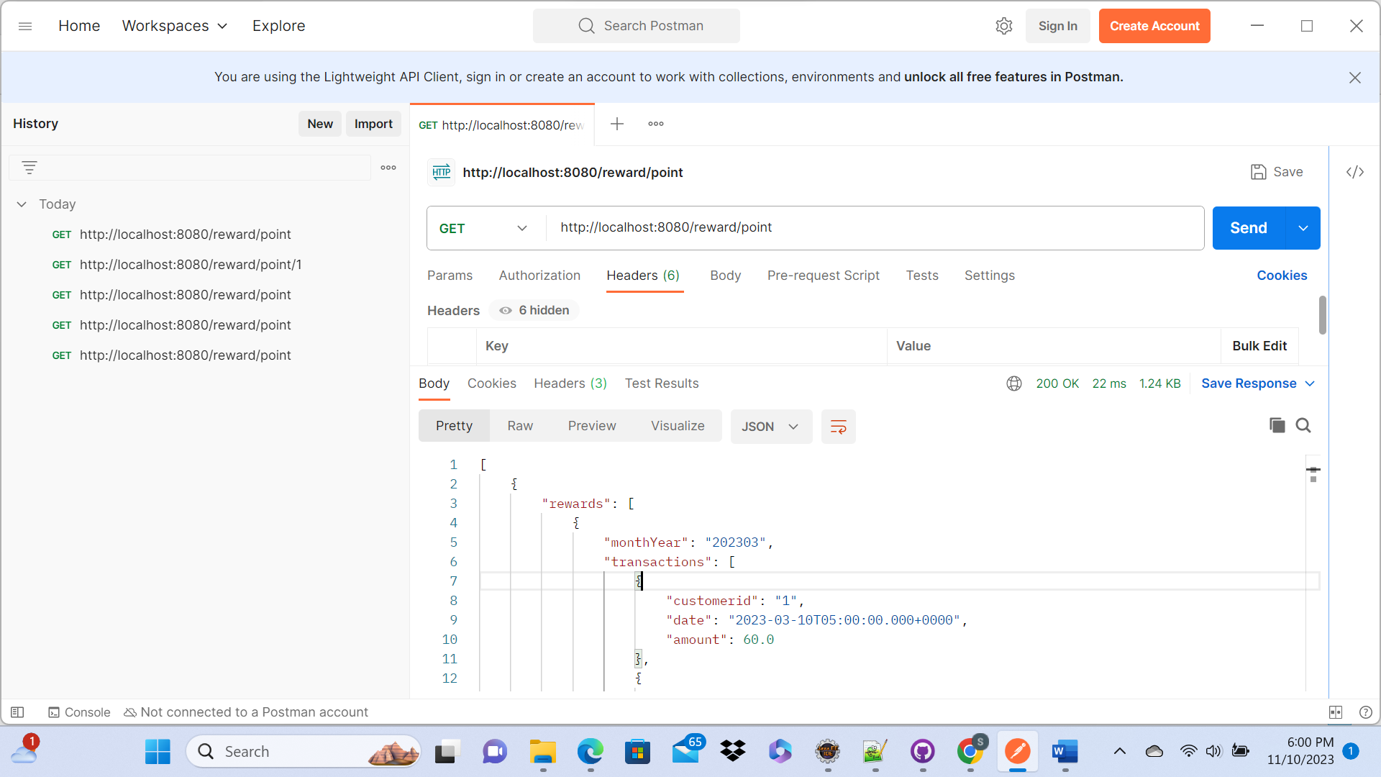

For one customer: <http://localhost:8080/reward/point/1>

{

    "rewards": [

        {

            "monthYear": "202303",

            "transactions": [

                {

                    "customerid": "1",

                    "date": "2023-03-10T05:00:00.000+0000",

                    "amount": 60.0

                },

                {

                    "customerid": "1",

                    "date": "2023-03-11T05:00:00.000+0000",

                    "amount": 40.0

                }

            ],

            "monthlyPoint": 10.0

        },

        {

            "monthYear": "202304",

            "transactions": [

                {

                    "customerid": "1",

                    "date": "2023-04-01T04:00:00.000+0000",

                    "amount": 140.0

                }

            ],

            "monthlyPoint": 130.0

        },

        {

            "monthYear": "202302",

            "transactions": [

                {

                    "customerid": "1",

                    "date": "2023-02-25T05:00:00.000+0000",

                    "amount": 120.0

                },

                {

                    "customerid": "1",

                    "date": "2023-02-26T05:00:00.000+0000",

                    "amount": 80.0

                }

            ],

            "monthlyPoint": 120.0

        }

    ],

    "totalPoint": 260.0

}

Screenshot

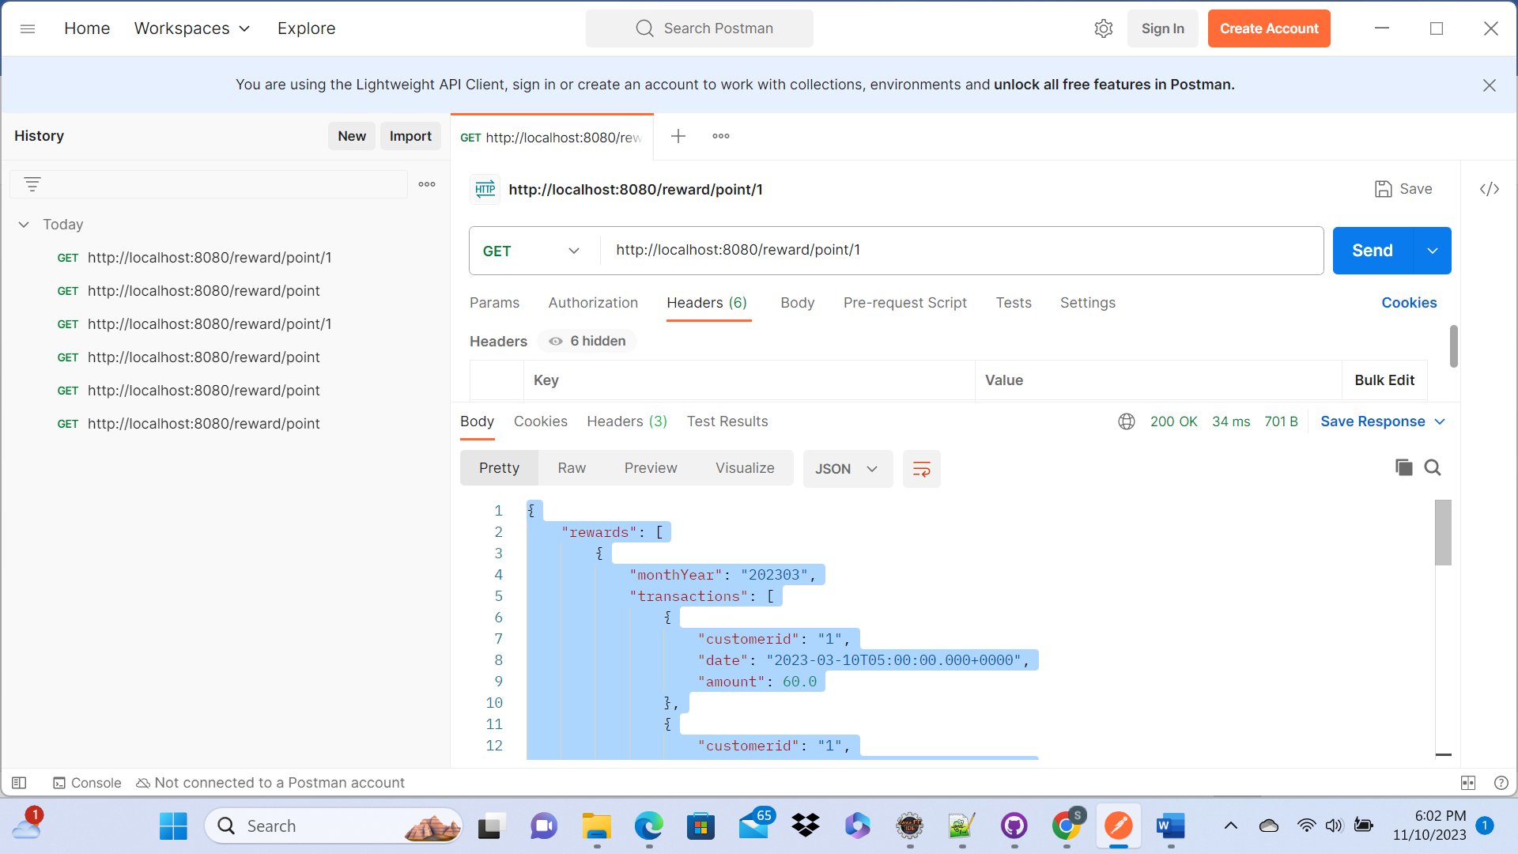

Actuator: http://localhost:8080/actuator/health

